**UNIT 1 MATHEMATICAL METHODS**

**TEST 2 TRIGONOMETRY**

**RESOURCE FREE**

**TOTAL MARKS: 19**

**TIME ALLOWED: 25 MINS**

**NAME: ______________**

**Question 1 (4 marks)**

If φ and λ are acute angles such that  and , find the *exact* value of

sin (φ + λ).

**Question 2 (3 marks)**

State the ***maximum*** value of  and the

corresponding value of x. (3 marks)

**Question 3 (6 marks)**



150

D

C

B

A

The diagram ABCD above (not drawn accurately) represents a garden. The sector BCD has

Centre B and DBC = 150or  The points A, B and C lie on a straight line and

AB = AD = 3 metres.

(a) Find the size of angle DAB and hence find the *exact* length of BD. (4)

(b) Calculate the outside perimeter of the garden ABCD.

Leave your answer in surd form. (2)

Question 4 (6 marks)

(a) The graphs of ,  and  are shown below.

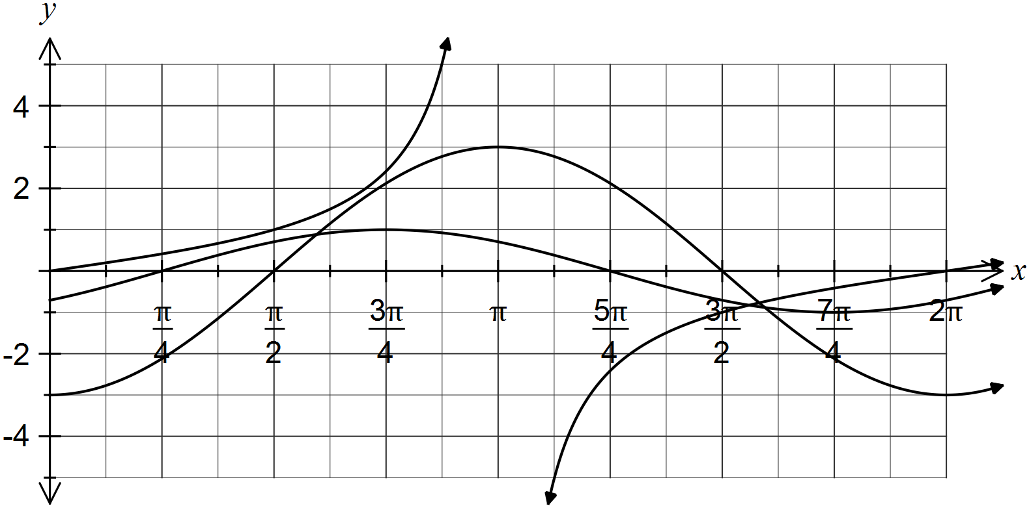

Determine the values of the constants a, b and c. (3 marks)

*b*) Complete the following table. (3 marks)

|  |  |  |
| --- | --- | --- |
| **Function** | **Period** | **Amplitude**  **(where applicable)** |
| y = 5 sin (3x°) |  |  |
| y = -6 cos ( $\frac{x}{4}$ + 30°) |  |  |
| v = 7 tan (2t + π) |  |  |

|  |  |  |  |  |  |
| --- | --- | --- | --- | --- | --- |
|  |  |  |  |  |  |

**UNIT 1 MATHEMATICAL METHODS**

**TEST 2 TRIGONOMETRY**

**RESOURCE RICH**

**TOTAL MARKS: 26**

**TIME ALLOWED: 35 MINS**

**NAME: ______________**

**Question 1 (2 marks)**

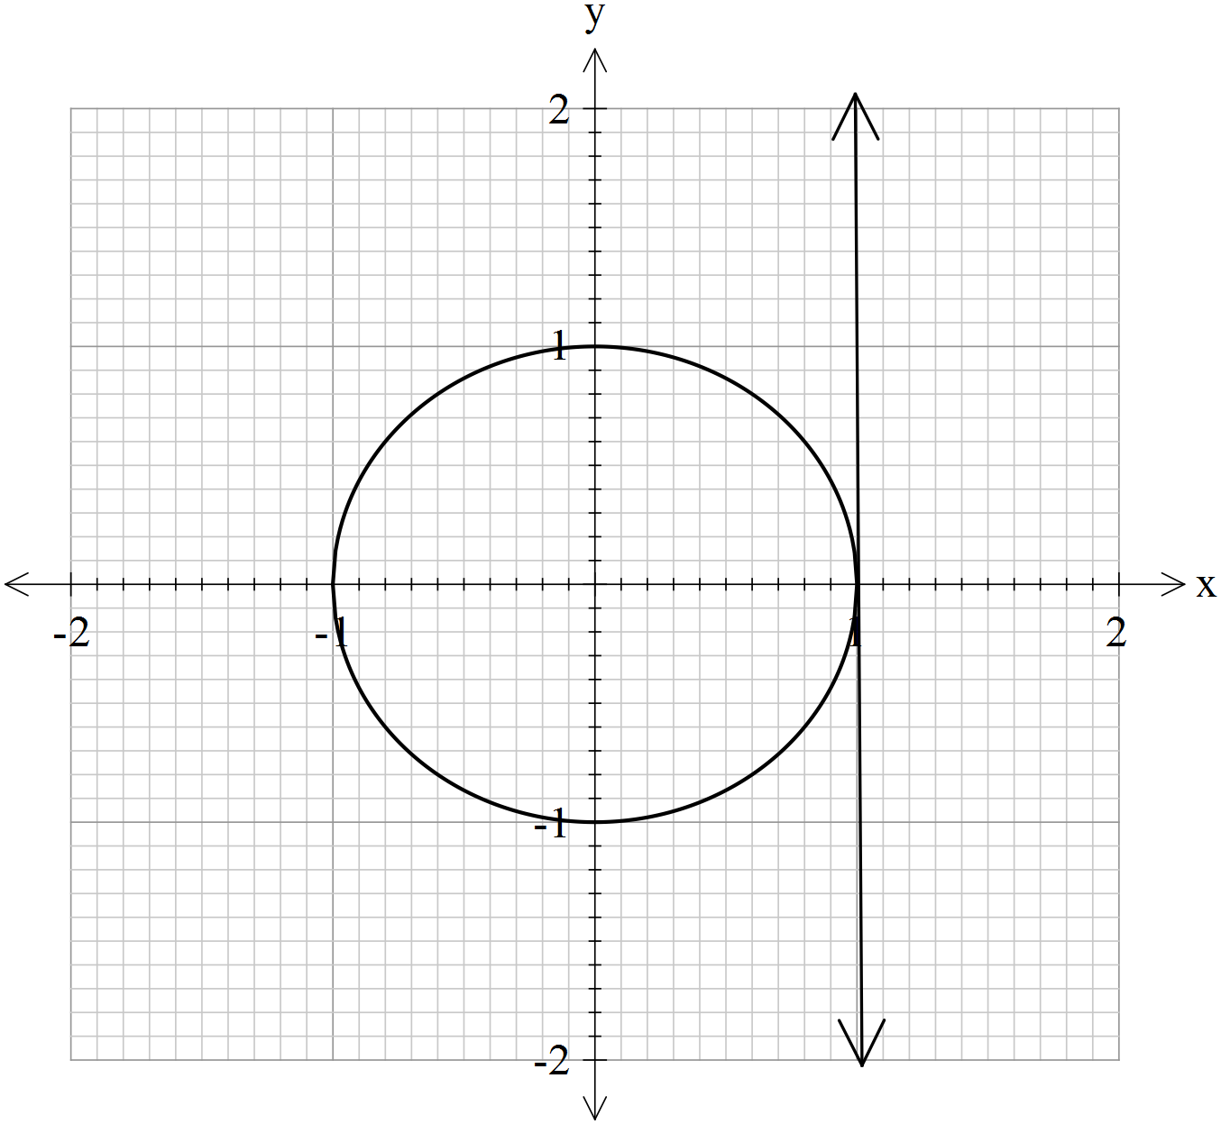

On the Unit circle above, show how the following are determined.

**(a)** 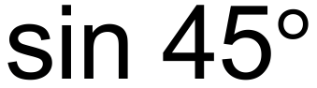 (1 mark)

**(b)** cos  (1 mark)

**Question 2 (6 marks)**

Determine the equations of the following graphs.

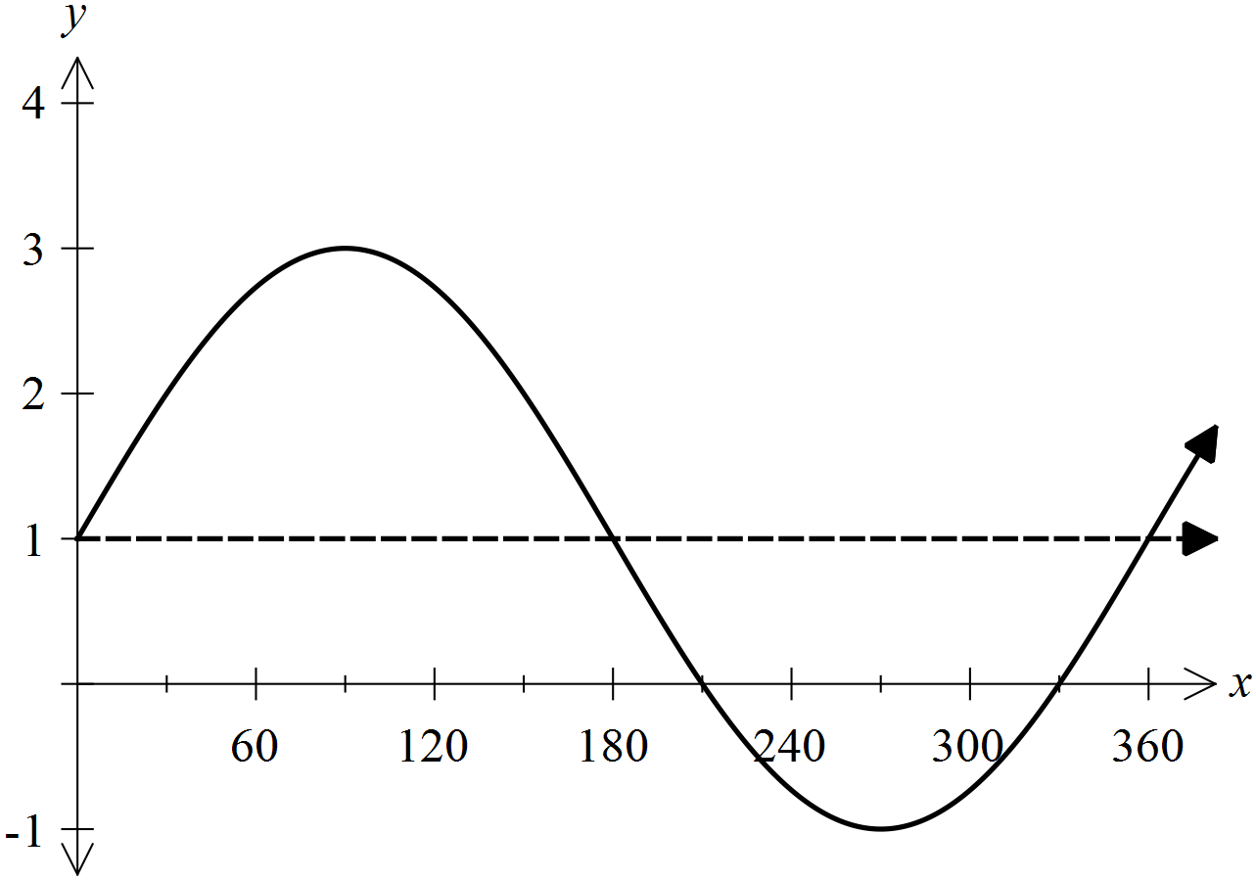**(a)** (2 marks)

**(b)** (2 marks)

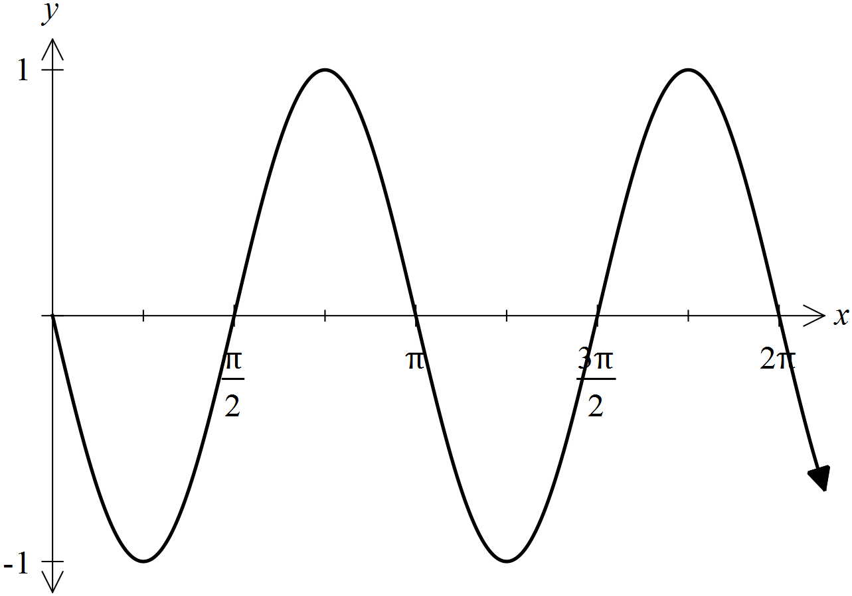

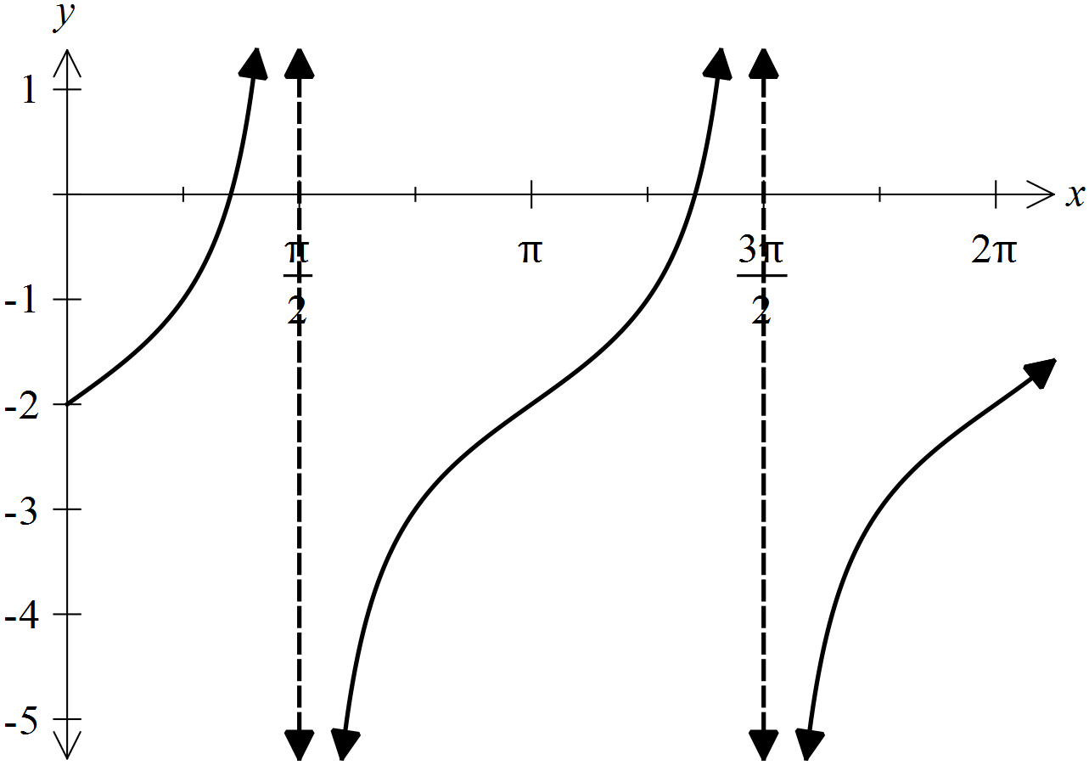**(c)** (2 marks)

**Question 3 (7 marks)**

In triangle $PQR$, $PR=50$ cm, $QR=30$ cm and $∠QPR=25°$.

(a) Show that $∠PQR$ can be $44.8°$ or $135.2°$. (3 marks)

(b) Showing use of trigonometry, determine

(i) the largest possible length of $PQ$. (2 marks)

(ii) the smallest possible area of triangle $PQR$. (2 marks)

Question 4 (6 marks)

A and B lie on the circumference of a circle of radius 20 cm.

The chord AB subtends an angle of  at O, the centre of the circle.

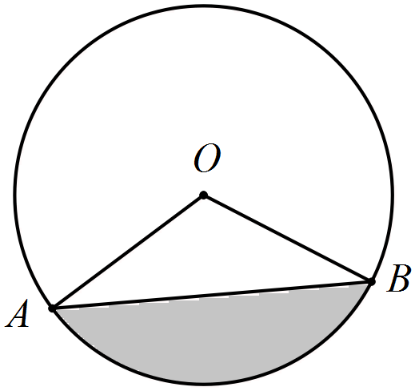

(a) Determine the exact length of the minor arc AB. (2 marks)

(b) Determine the length of the chord AB. (2 marks)

(c) Determine the shaded area bounded by the chord AB and the minor arc AB. (2 marks)

Question 4 (5 marks)

(a) The depth of water at a mooring in a tidal inlet during a particular day can be modelled by the function , where d is the depth of water in meters and t is the time in hours after midnight, as shown below.

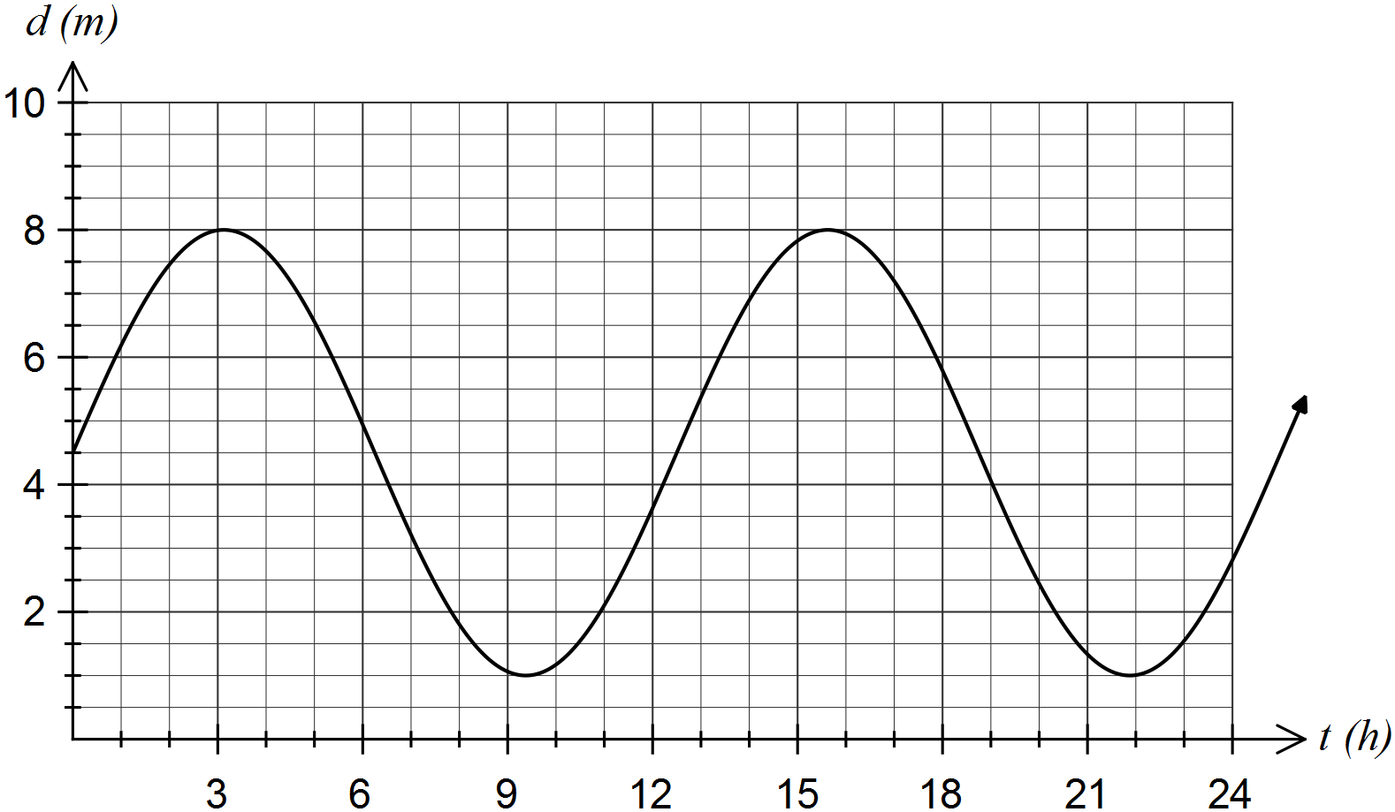

(i) Use your calculator to determine the time, to the nearest minute, at which the depth of water is first a minimum. (2 marks)

(ii) For what percentage of the first 12 hours is the depth less than 2 metres? Give your answer rounded to one decimal place. (3 marks)